Project Name |  | Confidentiality Level
DBMS Project |  | For Recipients’ Reference Only
Project ID | Version | Document Code

Database Management System Project User's Manual

Copyright ©DBMS12, Co., Ltd.
. All Rights Reserved
Revision Record
Date | Revision Version | CR ID /Defect ID | Sec No. | Change Description | Author

Content
1. Build Environment 4
1.1. Development environment 4
1.2. Data source 4
2. Function Description 5
2.1. Function name 1 5
2.2. Function name 2 5

Build Environment

Development environment
Type | Tools and environment
Development tools | Visual Studio 2013
Use of technology | C++,MFC
Operating environment | windows

Data source
Record all libraries with a txt file, each library has a same name folder, the folder to store the tables.

Function Description

2.1 Loading
Enter the user name and password.
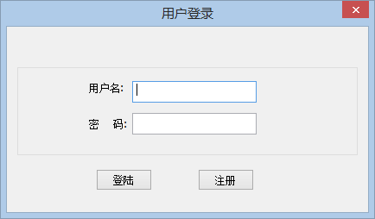

2.2 Create table
Select the table - > create table menu, show create table dialog box. Enter the table name in the dialog box. Create success after the tree view displays the name of the table.
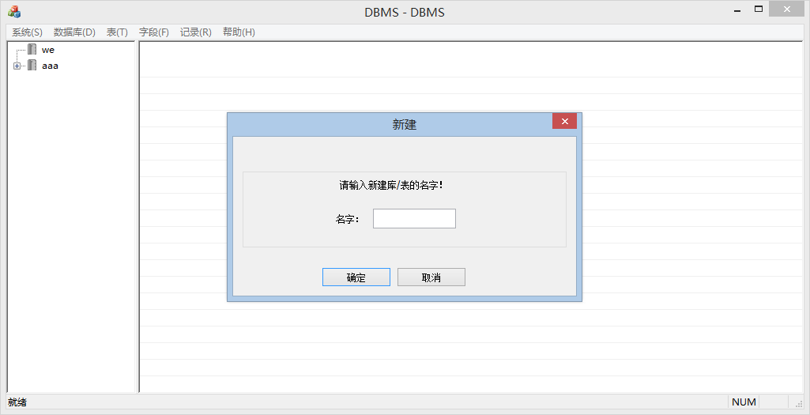

2.3 Add a field
Choose the field - > add menu, according to add fields dialog box, in the dialog input field name, type, default values, set the field constraints.
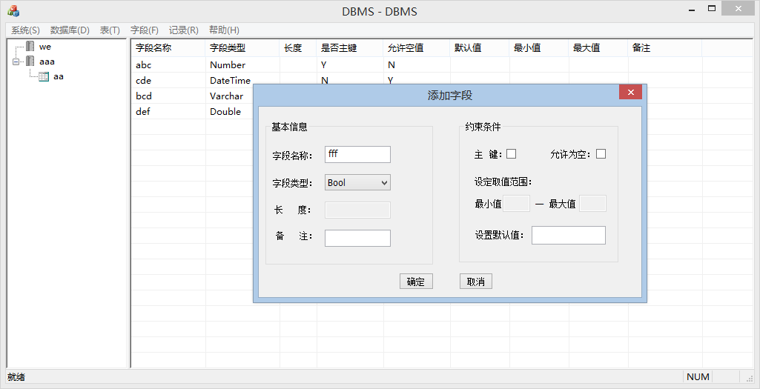
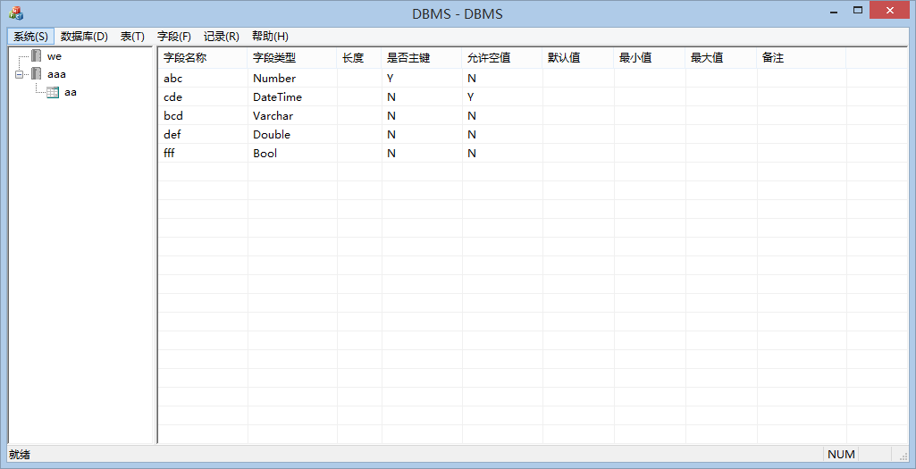

2.4 Insert
Choose the record - > insert menu, interface, insert records to show in the field name and field type insert recording interface, and enter the field values.
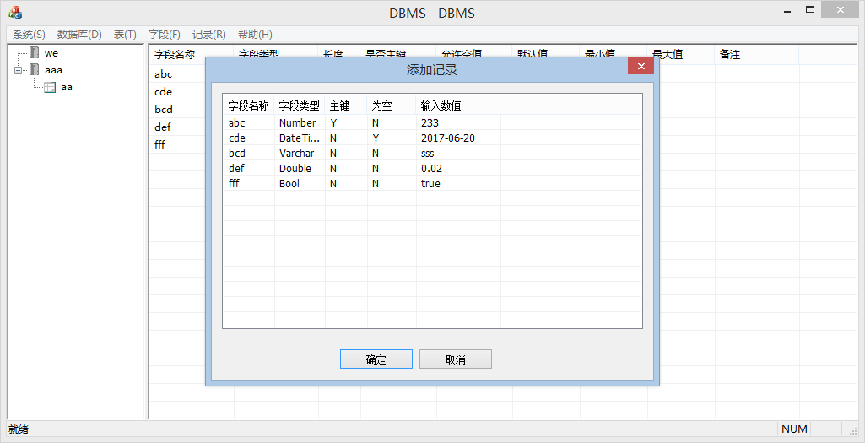

2.5 Delete
Choose the record - > delete menu, interface,then delete the record.

2.6 Update
Choose the record - > update menu, interface, update records to show in the field name and field type updating recording interface, and enter the field values.
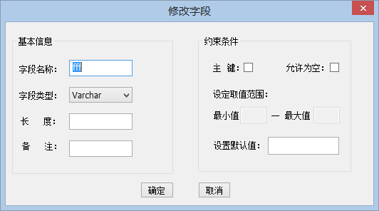

2.7 Select
Select "record - > query" menu, record in a table list to display in the list view.
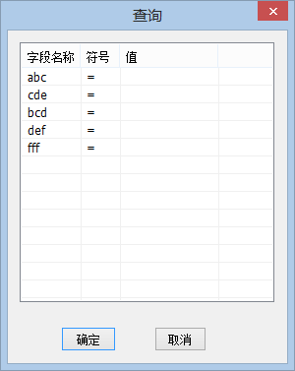

2.8 Index
Easy to find the records.

2.9 SQL statement parsing
For some simple SQL statement parsing
